/Repository from GitHub: https://vscode.dev/github/iamspruce/Simple-HTML-CSS-Portfolio/blob/main

Scope: Since this is a pilot study (48 outputs), choose representative UI types that exercise different accessibility and usability issues like portfolio website, restaurant landing website, e-commerce product page, and etc.
- Setup: 2 models x 3 UI prompts x 2 runs x 4 runs = 48 outputs
- Models: 2 frontier LLMs (e.g., ChatGPT 5.5, Claude Sonnet 5 Medium/Opus, Gemini, and etc.)
- Interface types: 3 static webpages
- Outputs: 48 final HTML documents
- Accessibility evaluation: 20-25 WCAG 2.2 Level A/AA/AAA success criteria applicable to static HTML/CSS interfaces.
- Usability evaluation: All 10 Nielsen heuristics.
- Excluded features: PHP, Ajax, Multimedia, dynamic JavaScript applications, authentication, drag-and-drop, gesture-based interactions, real-time communication, and other criteria requiring functionality beyond static webpages.

Prompt A — WCAG only: “You are an accessibility engineer. Revise the HTML document I provide so that it conforms to WCAG 2.1 Level AA. Address the relevant success criteria: semantic landmarks, heading order, image alt text, form labels, colour contrast, focus visibility, link purpose, language attributes, and ARIA correctness (including roles that require specific child elements). Preserve all visible text content, links, and page structure. Do not reword, add, or remove user-facing copy except where a fix requires it (for example, giving an empty link discernible text). Return the complete corrected HTML document and nothing else — no explanation, no commentary, no markdown code fences. Keep all relative paths (styles.css, assets/…) unchanged.”

Prompt B — WCAG + Nielsen: “You are an accessibility and usability engineer. Revise the HTML document I provide so that it conforms to WCAG 2.1 Level AA and satisfies Nielsen's 10 usability heuristics. WCAG concerns: semantic landmarks, heading order, image alt text, form labels, colour contrast, focus visibility, link purpose, language attributes, and ARIA correctness (including roles that require specific child elements). Nielsen's 10 heuristics: (1) visibility of system status; (2) match between the system and the real world; (3) user control and freedom; (4) consistency and standards; (5) error prevention; (6) recognition rather than recall; (7) flexibility and efficiency of use; (8) aesthetic and minimalist design; (9) help users recognise, diagnose, and recover from errors; (10) help and documentation. Where WCAG and a heuristic conflict, satisfy WCAG. Preserve all visible text content and links; you may restructure or add markup where a heuristic requires it, but do not invent new page sections or rewrite the author's copy. Return the complete corrected HTML document and nothing else — no explanation, no commentary, no markdown code fences. Keep all relative paths (styles.css, assets/…) unchanged.”

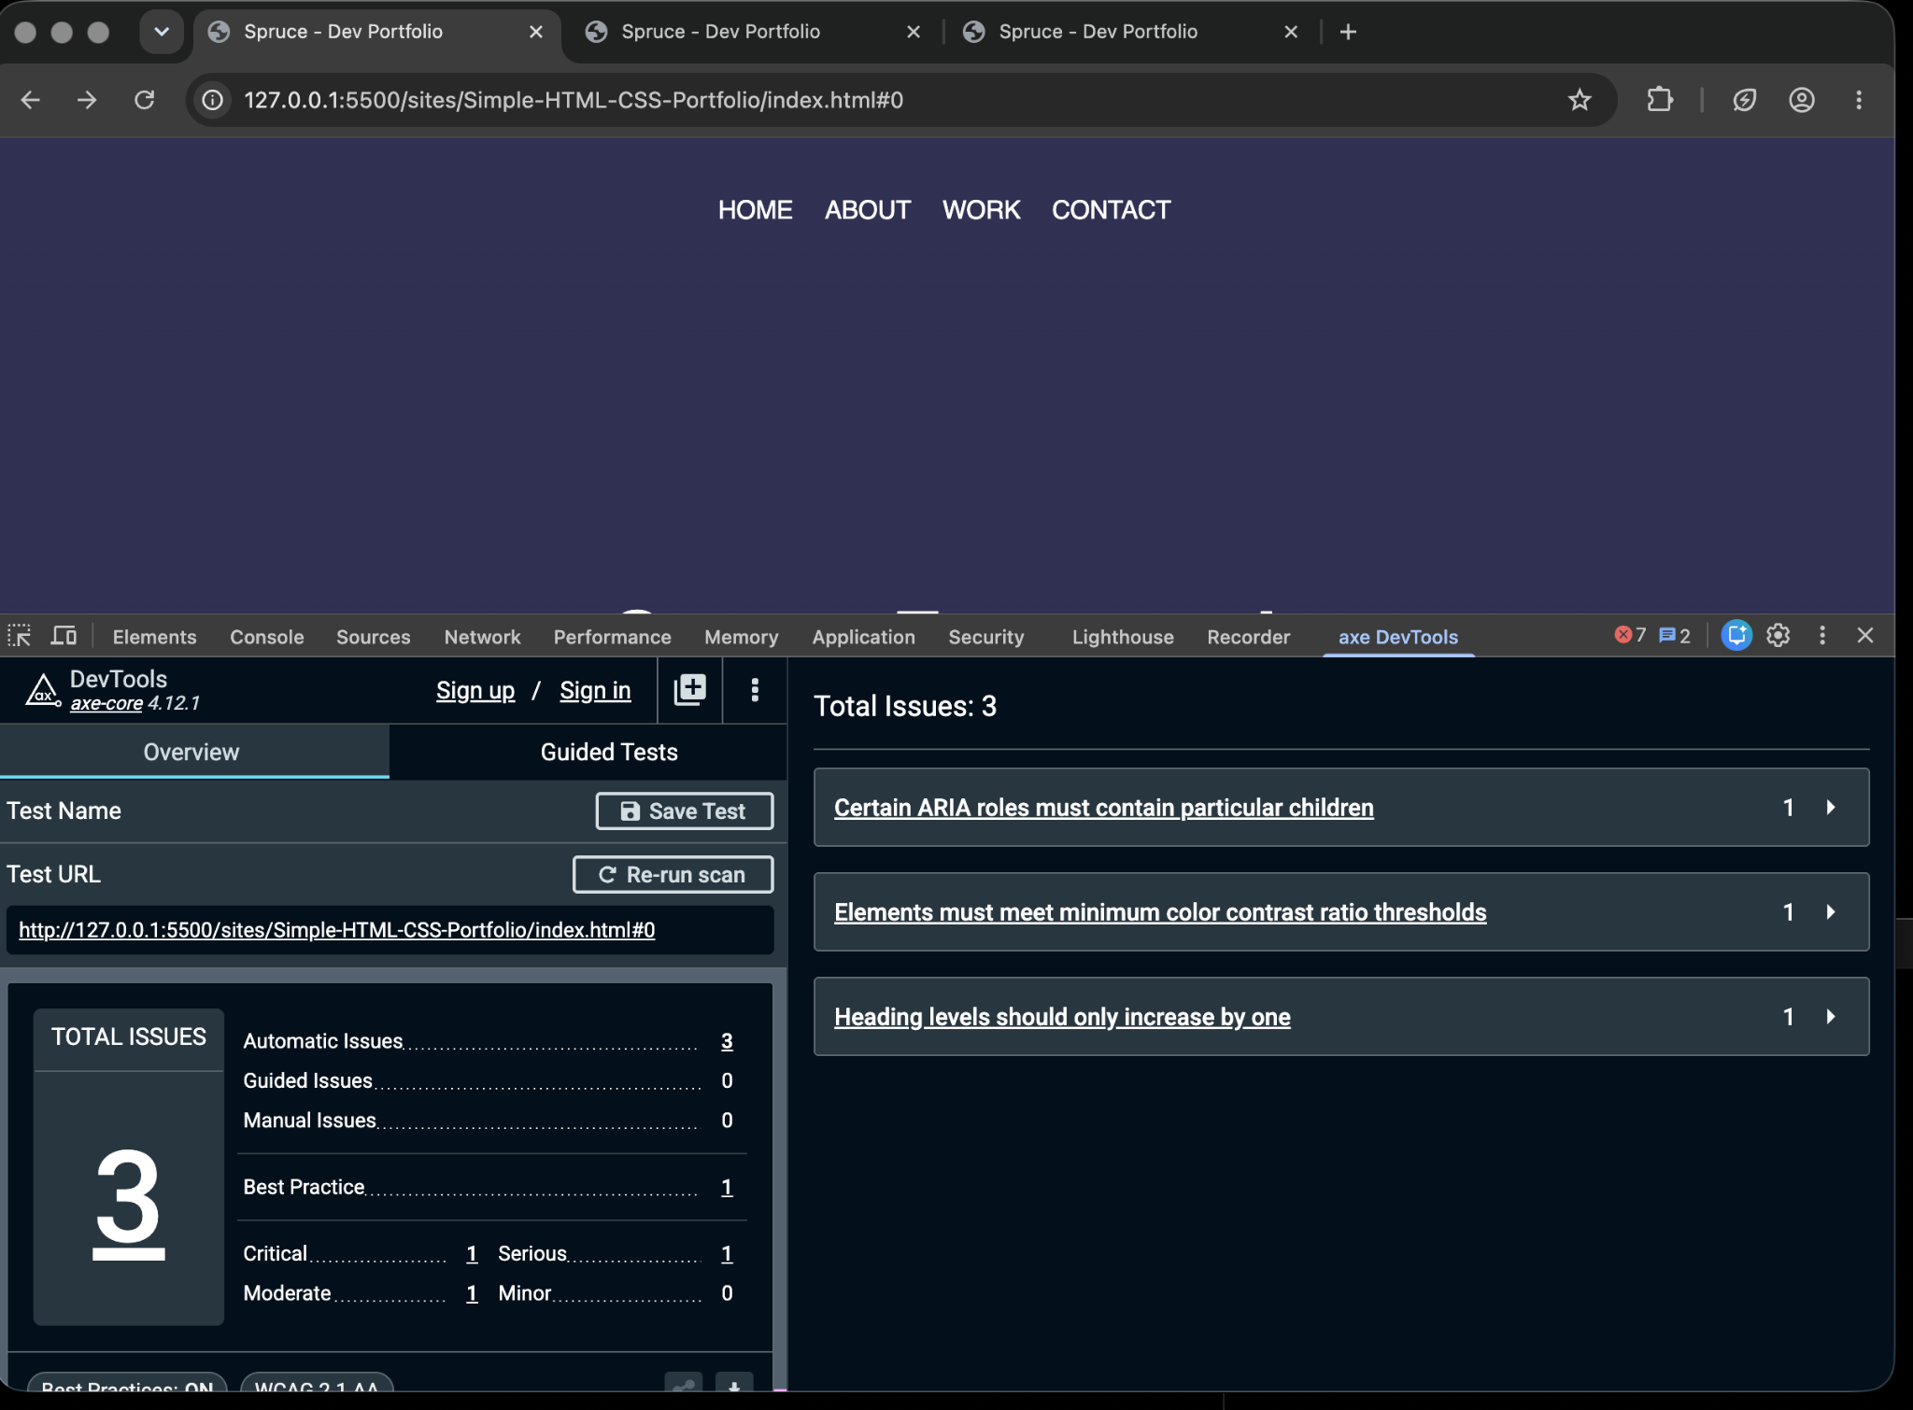
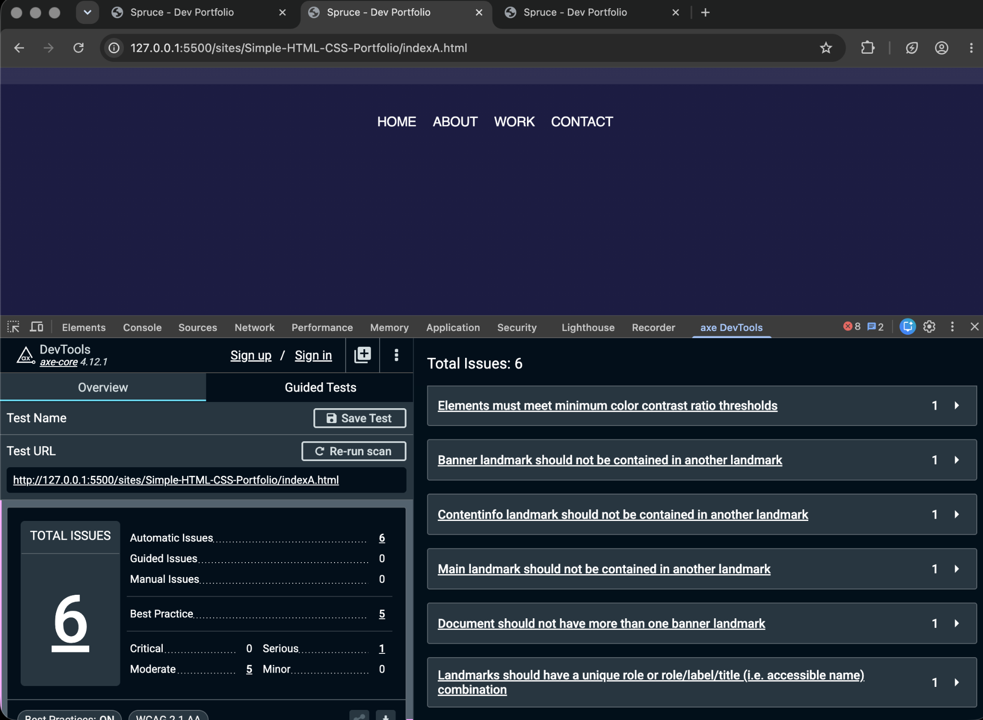
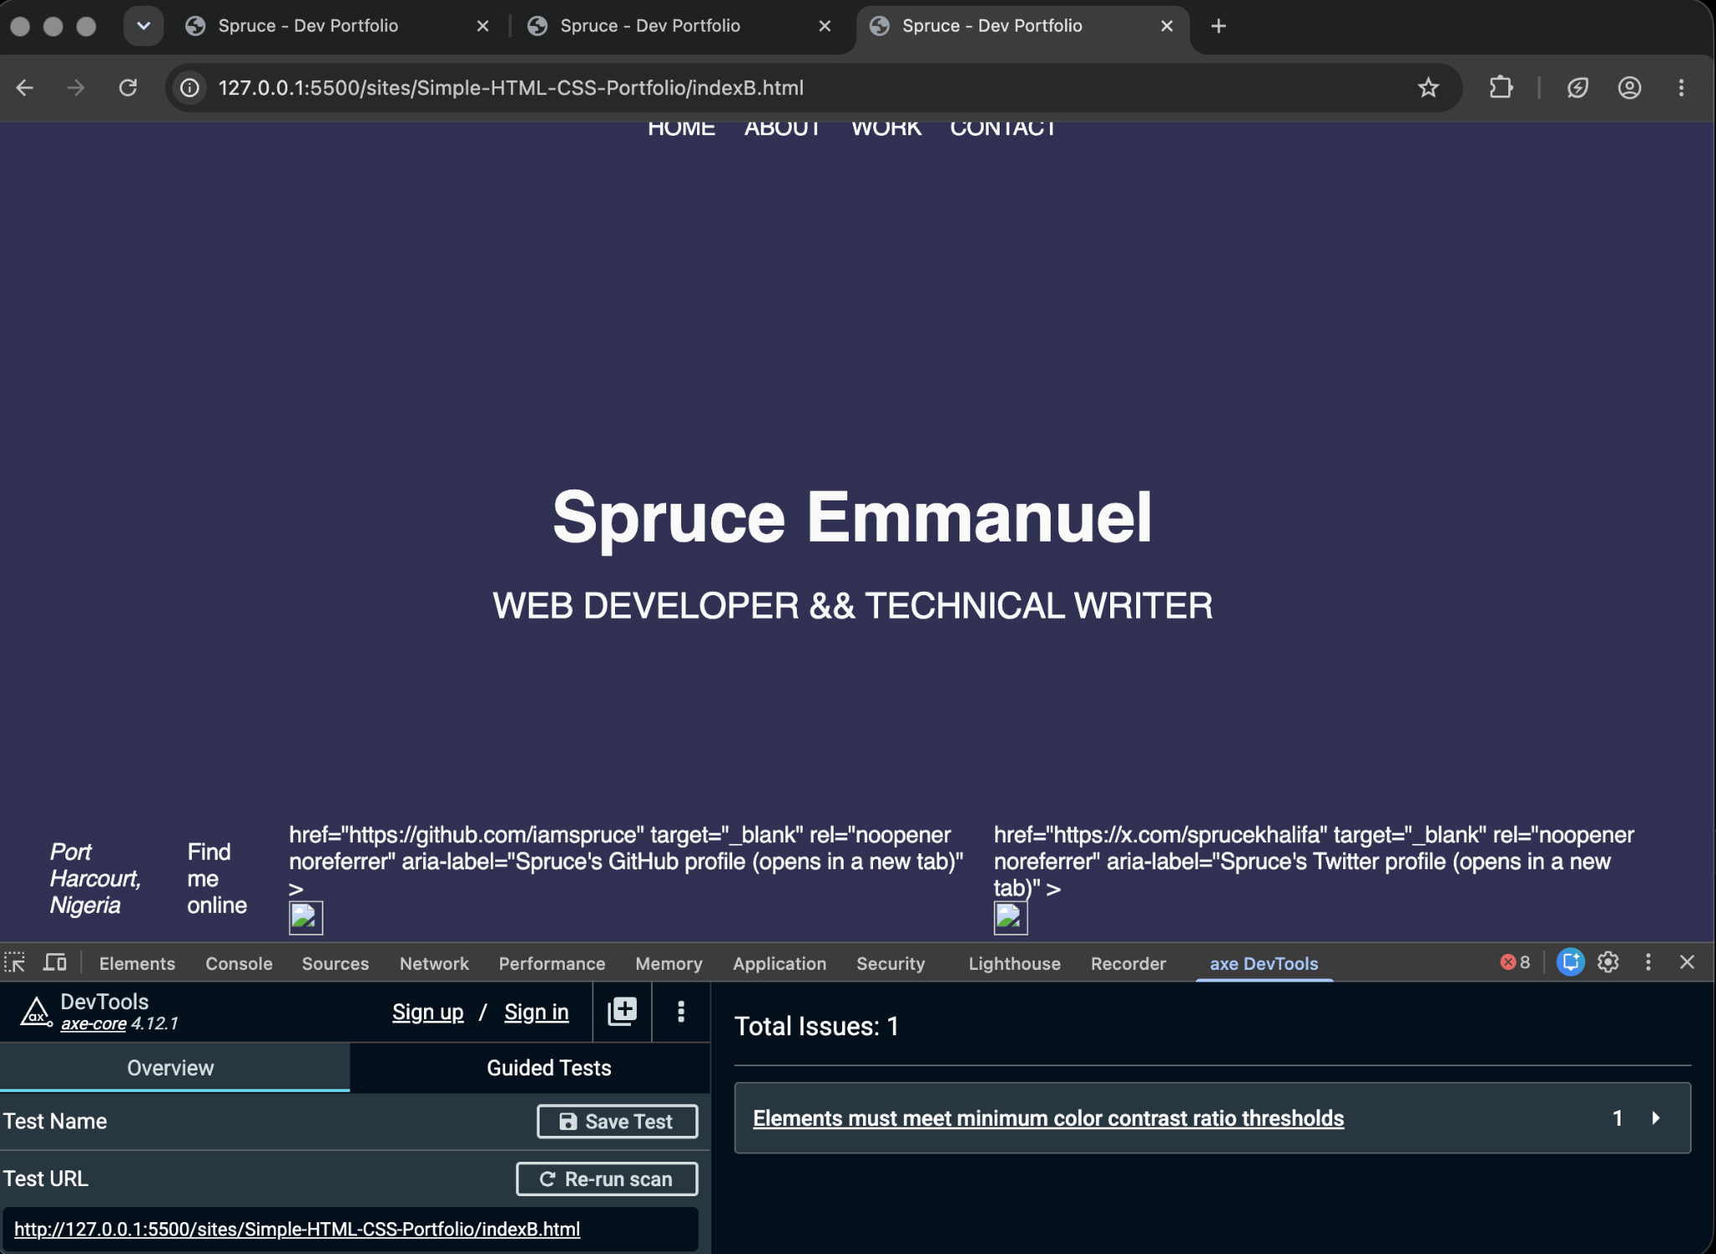

We used axe dev tools to evaluate a simple website and prompt, but the results are quite interesting. Accessibility focused prompt increased the amount of issues, whereas accessibility + usability prompt reduced the issues.

Model(s): Claude Sonnet 5 Medium

Same Prompt A and Prompt B but with ChatGPT
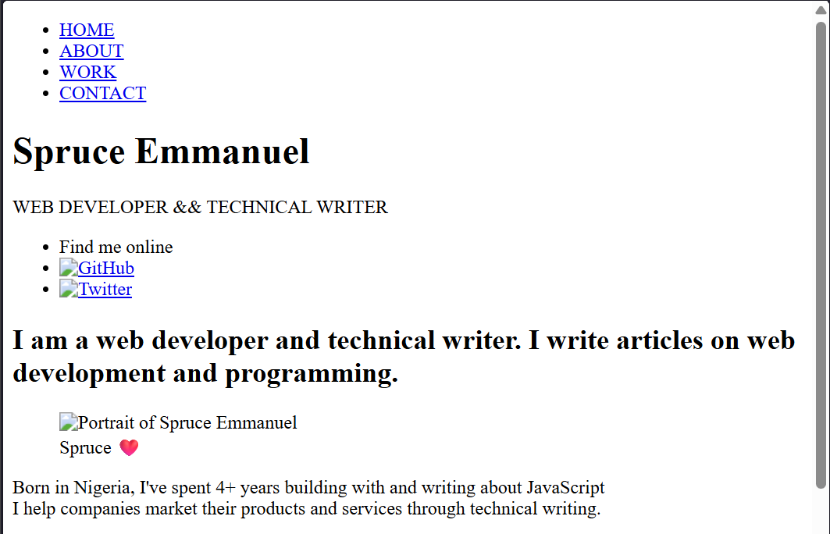

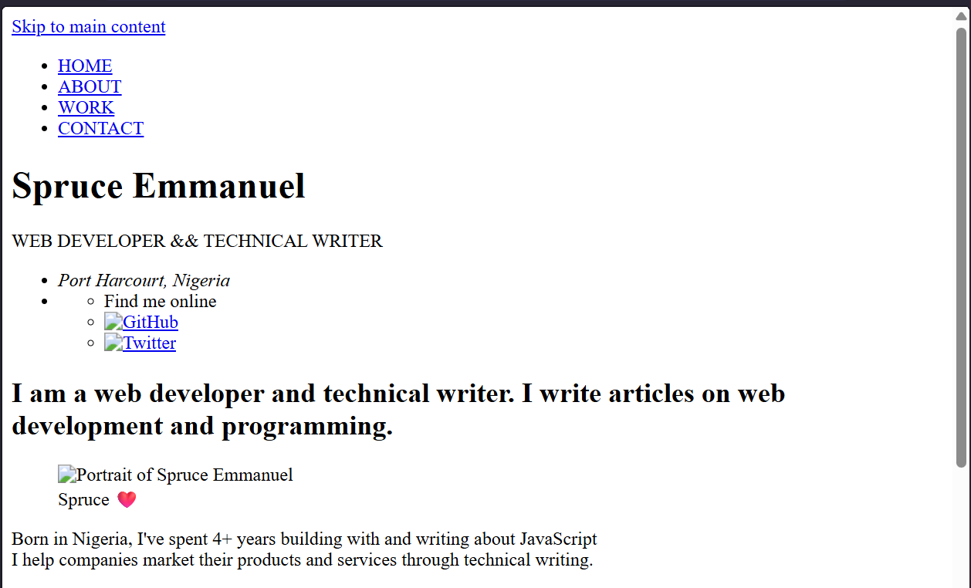
PILOT

3 types of UIS
- E-commerce
- Portfolio
- Restaurant menu

4 prompts
- Baseline
- WCAG (with WCAG JSON)
- Nielsen's heuristics (with Nielsens JSON)
- WCAG + heuristics (with WCAG and Nielsens JSON)

Method:
Run a loop with an LLM where it first evaluates the website using the resources provided to it with respect to each prompt, and then improves the website based on its evaluation. This loop runs till the LLM generates the same code again or when it hits 3 iterations.

Test run with 1 model, 1 UI, 4 prompts
UI: git clone https://github.com/bearlike/Pixel-Portfolio-Webite.git

Base website:

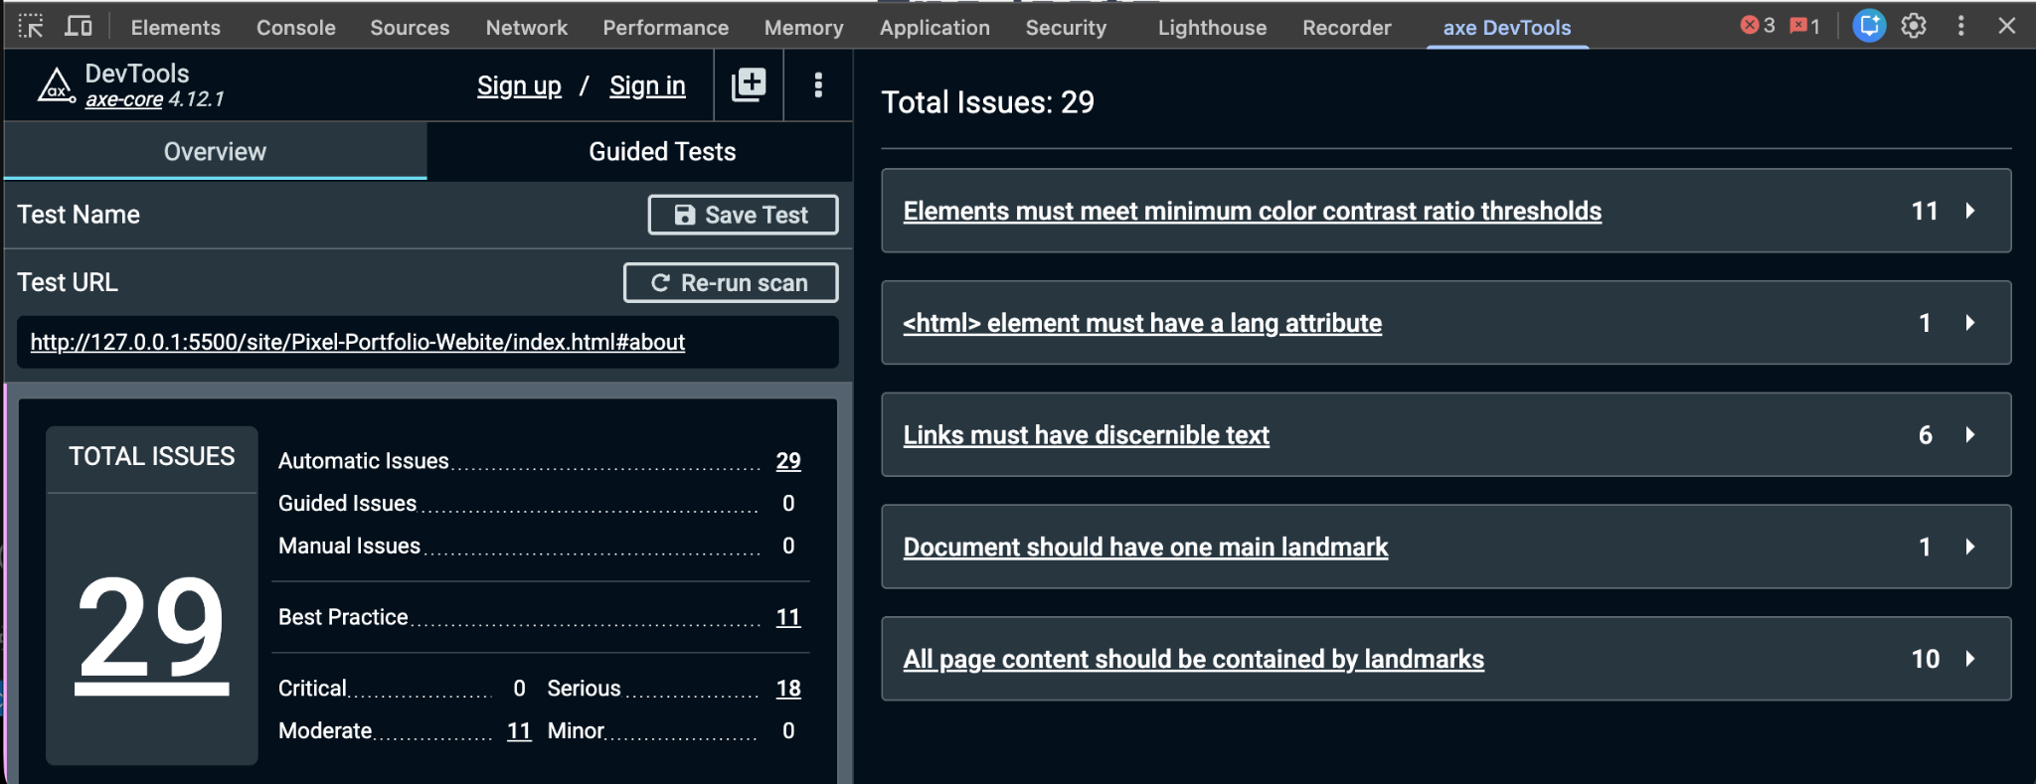

- Naive prompt

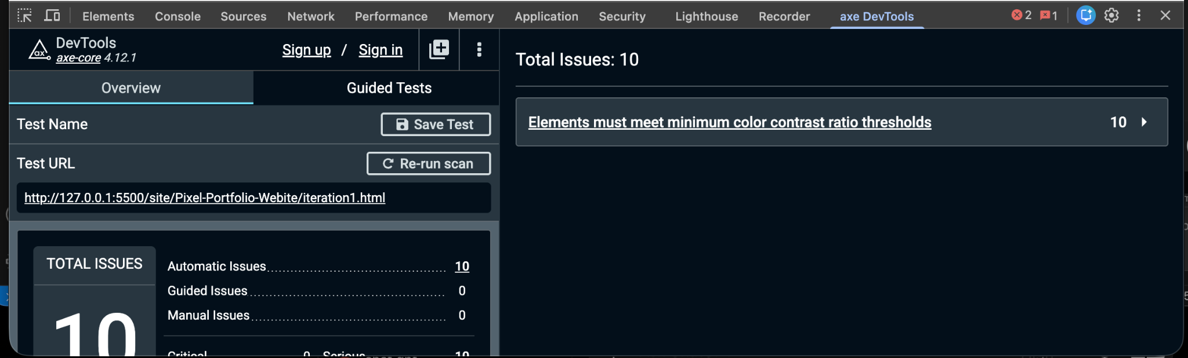

- Wcag prompt
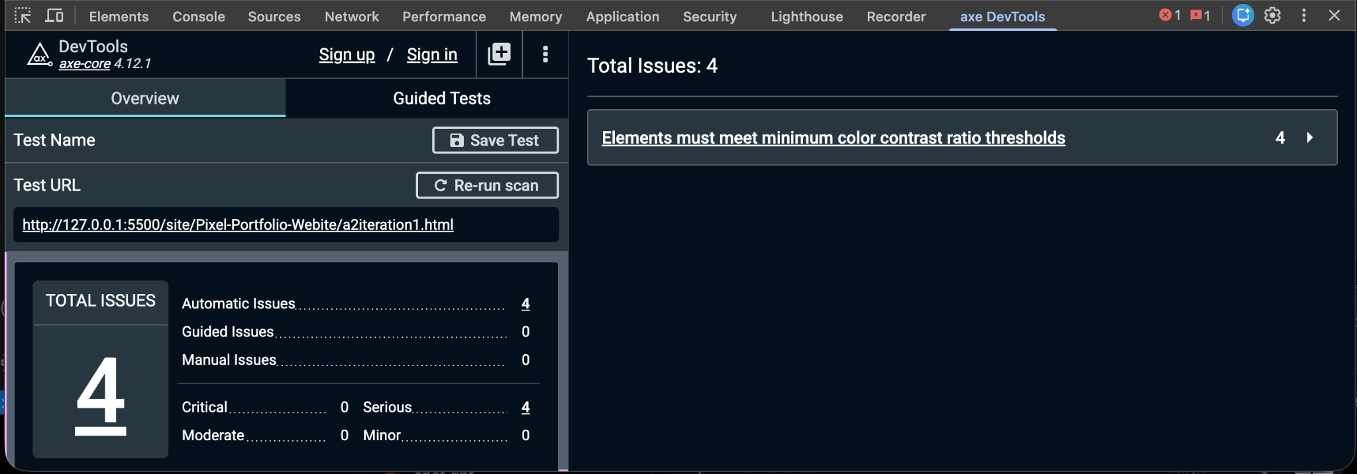

- Nielsen prompt
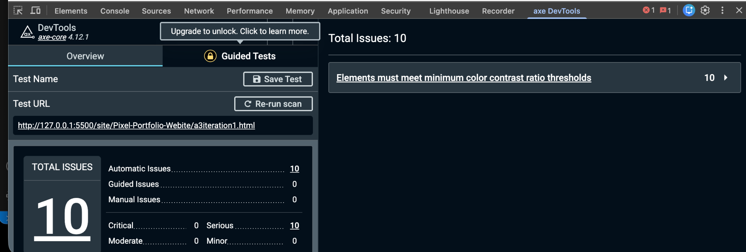
- WCAG + Nielsen prompt